Piecewise Vehicle Performance Modeling
from Onboard Diagnostic Measurements
Jiale Jiang, Emily Robinson, Hector Rodruguez, and Yaoyi Peng
Mt. San Antonio College
September 27, 2026

Abstract—We developed piecewise vehicle models from three Volkswagen Jetta and three Toyota Camry OBD records. A linear acceleration model produces quadratic velocity and cubic position, while separate RPM and fuel-rate fits represent acceleration and braking. We compare this model with constant acceleration using recorded-speed residuals, then estimate four unrecorded driving courses. The results describe similar driving inputs; cruise operation and travel beyond the recorded speed range require additional assumptions. The quarter-mile scenario predicts 24.2 s for the Jetta and 28.9 s for the Camry, but three short low-speed trials do not establish a statistical uncertainty interval for these extrapolations.

I. Introduction
The purpose is to predict travel time, distance, engine RPM, and fuel use for courses that were not measured directly [1]. We use low-order equations because the records contain speed and engine information but no consistent throttle, brake, or gear input. These are empirical driving-scenario models, not a feedback controller or a test of maximum vehicle performance.

II. Measurements and Processing
The recorded procedure was to park on relatively flat pavement, start logging before launch, accelerate toward 35 mph, and decelerate toward rest. Three logs were retained for each vehicle. The project used OBD Fusion; the Jetta is identified as a 2022 SE in the source code. The Camry year and powertrain are not confirmed. A repeated test should use the same route, driver, vehicle load, and approximate pedal input, with logging operated while stationary or by a passenger.
TABLE I
RECORDED TRIAL COVERAGE
Trial | Rows | Span (s) | Rows/s | Peak mph
J1 | 156 | 18.84 | 8.23 | 34.80
J2 | 130 | 16.40 | 7.86 | 36.66
J3 | 141 | 16.56 | 8.46 | 37.28
C1 | 481 | 24.01 | 19.99 | 35.42
C2 | 510 | 25.45 | 20.00 | 34.18
C3 | 457 | 22.80 | 20.00 | 34.80
J = Jetta; C = Camry. Row rate = (N − 1)/elapsed time; this does not establish the refresh rate of each signal.
Jetta logs contain time, speed, RPM, app acceleration, trip distance, trip fuel, and instantaneous/total MPG. Camry logs contain time, speed, RPM, and fuel mass rate. We convert mph to ft/s by multiplying by 5280/3600, and lb/min to lb/s by dividing by 60. Cumulative trapezoidal integration of speed gives distance; integrating fuel rate gives fuel used. Camry fuel stays in lb of mass, not gallons. Figs. 1–2 show all three records for each vehicle.
Jetta trial 3 has a repeated final timestamp, which remains in the raw records. Camry speed is often held across adjacent rows, and all three records end near 1.86 mph rather than at a measured stop. For model fitting, launch begins at the last zero before peak speed; braking runs from the last peak to the first subsequent zero or the record end. These selections exclude long stationary periods from the moving fits.
Differentiating quantized speed amplifies noise. The Kalman filter estimates speed and acceleration together, predicting their next values and correcting the prediction with observed speed [4]. We use it to display smoother acceleration estimates, accepting some lag. The motion fits and their errors use recorded speed, so the filtered acceleration is not treated as independent ground truth.

III. Piecewise Models
Let τ be time since a phase begins, v₀ its initial speed, and x₀ its starting position. We fit initial acceleration a₀ (ft/s²) and jerk j (ft/s³), then integrate the same equation for velocity and position:
a = a₀ + jτ (1)
v = v₀ + a₀τ + ½jτ² (2)
x = x₀ + v₀τ + ½a₀τ² + (j/6)τ³ (3)
The constant-acceleration baseline sets j = 0. Direct fminsearch calls minimize squared velocity residuals [3]; the acceleration endpoints are constrained to keep the correct sign over the fitted interval. The same initial velocity and samples are used for both models. Table II reports fitting error, not accuracy on an independent course.
RMSE = √[mean((vmodel − vrecorded)²)] (4)
TABLE II
MOTION COEFFICIENTS AND VELOCITY RMSE
Phase | a₀ | j | Const. a | Linear a
J accel | 14.628 | -1.931 | 4.47 | 2.58
J brake | -9.631 | 0.944 | 10.30 | 8.82
C accel | 8.227 | -0.666 | 6.15 | 2.61
C brake | -6.696 | 0.285 | 3.55 | 3.14
a₀ in ft/s²; j in ft/s³; the last two columns are RMSE in ft/s. Figs. 3–4 show sample spread as well as the fitted curves.
Linear acceleration reduces the fitted velocity error for these records, especially during launch. It does not remove differences in driving input: Jetta braking varies substantially between runs, so a single pooled braking law is only a representative scenario. A lower fitting error alone does not demonstrate better prediction of an unseen driver.
RPM is fitted against speed separately during acceleration and braking with polyfit and evaluated with polyval [2]. These curves describe phase averages, not identified gears. Substituting modeled speed gives RPM versus time; stationary RPM uses a typical initial-idle value averaged across trials. Fuel rate is linear in speed except for Jetta braking, where a constant sample mean gives a coarse phase average and does not resolve transient spikes. Invalid speed/MPG ratios are excluded before fitting; negative fuel predictions are clipped to zero. The formulas are:
RPM = c₂v² + c₁v + c₀ (5)
qf = max(0, b₁v + b₀), F = ∫qf dt (6)
TABLE III
RPM AND FUEL COEFFICIENTS
Phase | [c₂, c₁, c₀] | [b₁, b₀]
J accel | -2.46, 169, 875 | 2.31e-05, 0.000685
J brake | 0.538, 10.4, 753 | 0, 0.000119
C accel | -0.383, 14.7, 2.25e+03 | -1.13e-05, 0.00455
C brake | 0.485, -9.83, 773 | -1.08e-05, 0.00066
Use v in ft/s. RPM is rpm. Fuel output is gal/s for Jetta and lb/s for Camry; coefficient units follow from these inputs/outputs.
Initial-idle estimates are 877 rpm and 9.74e-05 gal/s for Jetta; 1324 rpm and 0.00121 lb/s for Camry.
Negative launch jerk means acceleration tapers as the phase proceeds. The RPM and fuel coefficients describe empirical speed dependence, not gear ratios or engine torque. At idle, speed and acceleration are zero, position is constant, and fuel accumulates at an estimated idle rate. Jetta moving fuel rate is speed(mph)/(3600 × MPG) where MPG is positive; its idle rate comes from trip-fuel counter changes. Camry rate is recorded directly. Cruise fuel uses the midpoint of acceleration and braking rates at the target speed because steady-cruise data were not collected.

IV. Course Predictions
Course 1 reaches 15 mph and then cruises to 300 ft. Course 2 reaches 25 mph, cruises for the remaining distance, and brakes to rest at 600 ft. Course 3 covers 1320 ft at an average of 15 mph, so total time is 60 s; we choose a rest-to-rest acceleration/cruise/braking profile and solve for cruise speed. Course 4 accelerates throughout 1320 ft. Each course starts at launch, without an added idle period.
A decreasing linear acceleration eventually becomes negative, so extending the fitted polynomial indefinitely would violate Course 4. At a positive-acceleration boundary within the common launch-data interval, we instead continue acceleration with exponential decay. Position and velocity remain continuous:
a = ab exp(−u/T), u = t − tb (7)
v = vb + abT[1 − exp(−u/T)] (8)
x = xb + vbu + abT{u − T[1 − exp(−u/T)]} (9)
The boundary values are tb, xb, vb, and ab; T = −ab/j matches the acceleration slope at that boundary. This is a physical continuation assumption, not a fitted high-speed law. Separately, above the highest recorded speed, RPM uses a constant RPM/speed ratio and fuel rate is held at its value at that speed. These choices limit confidence in the quarter-mile result.
TABLE IV
JETTA COURSE PREDICTIONS
No. | Total s | Accel s | Brake s | Final mph | gal
1 | 14.45 | 1.69 | 0.00 | 15.00 | 0.0100
2 | 20.62 | 3.17 | 5.06 | 0.00 | 0.0145
3 | 60.00 | 1.77 | 2.74 | 0.00 | 0.0390
4 | 24.22 | 24.22 | 0.00 | 43.22 | 0.0441
TABLE V
CAMRY COURSE PREDICTIONS
No. | Total s | Accel s | Brake s | Final mph | lb
1 | 15.09 | 3.05 | 0.00 | 15.00 | 0.0419
2 | 22.31 | 5.83 | 6.33 | 0.00 | 0.0505
3 | 60.00 | 3.27 | 3.80 | 0.00 | 0.1406
4 | 28.90 | 28.90 | 0.00 | 37.53 | 0.1170
The maximum modeled launch acceleration is 14.63 ft/s² for Jetta, 8.23 ft/s² for Camry. Figs. 5–6 show distance, velocity, acceleration, RPM, fuel rate, cumulative fuel, and fuel economy for all four courses. Camry economy is mi/lb; a justified fuel density is needed to report MPG.

V. Discussion and Conclusion
The low-order model captures the curvature of launch speed with few parameters and provides consistent position, speed, and acceleration. Its practical use is estimating similar low-speed maneuvers and comparing clearly defined scenarios. Jetta braking variability, unknown gears, unmeasured cruising, and the Camry stopping tail limit stronger claims. New tests should prioritize steady cruise and repeated braking with similar inputs before increasing polynomial degree.
Volkswagen specifies 158 hp and 184 lb-ft for the 2022 Jetta 1.5 L engine [5]. Those ratings provide vehicle context, but these speed-only fits cannot independently recover engine torque or rated power. Nor can the fitted low-speed launches establish full-throttle quarter-mile performance. The next useful check is to predict a separate course before running it, then compare elapsed time and fuel with the recorded results.

References
[1] Mt. San Antonio College, Epic Quest 1d; Project 1 Overview v2; EpicQ1 grading rubric; and instructor virtual-course instructions. Course materials.
[2] MathWorks, “polyfit” and its polynomial evaluation examples. Online documentation
[3] MathWorks, “fminsearch.” Online documentation
[4] MathWorks, “Linear Kalman Filters.” Online documentation
[5] Volkswagen, “Updating the 2022 Jetta and Jetta GLI.” Online documentation
[6] Team records, JettaData.mat, CamryData.mat, DataParser.m, and SpeedKalmanFilter.m. Analysis dated September 27, 2026.
Electronic appendix: the original workspaces and DataParser.m retain all six trial tables. “Jetta recorded trials.png” and “Camry recorded trials.png” show complete traces; the fitting and course images below are also supplied separately at full resolution.

Jetta recorded trials
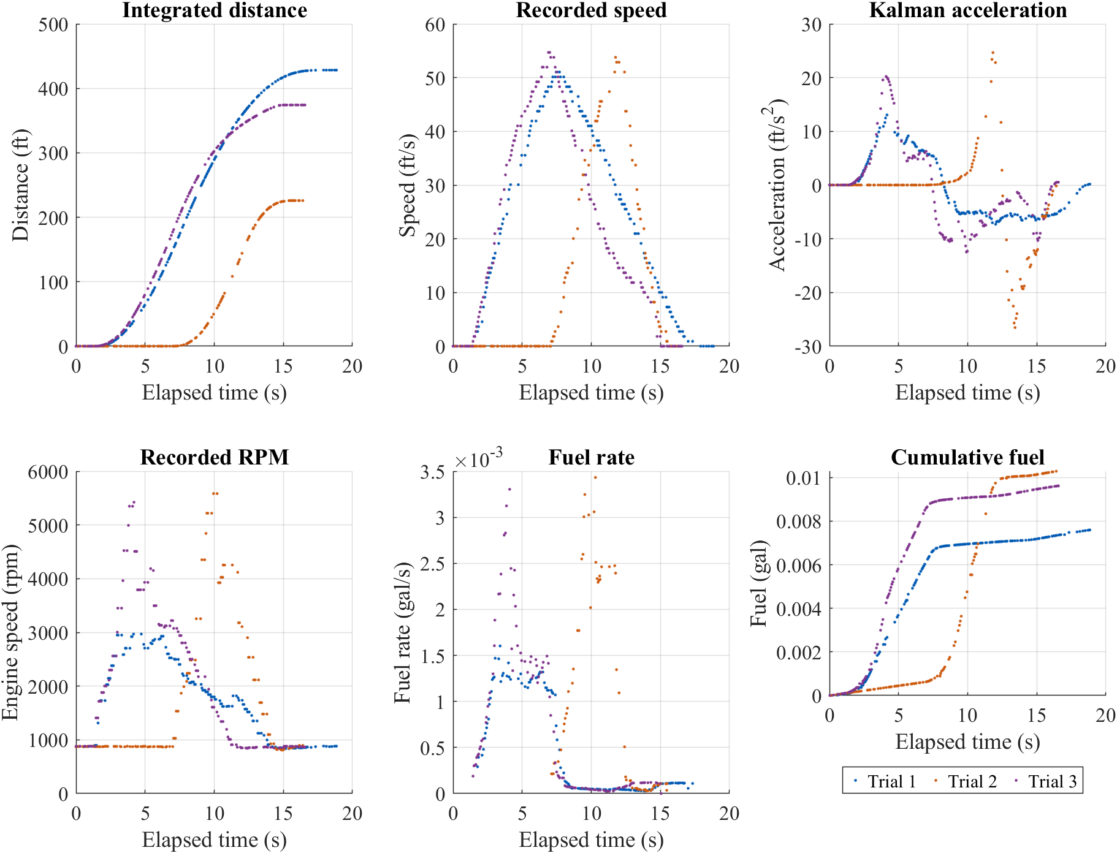
Fig. 1. Complete Jetta records plotted as discrete samples. Distance is integrated from speed; acceleration is the Kalman estimate. Cumulative fuel is the increase after the first positive trip-fuel value. Missing idle speed/MPG ratios remain gaps in the fuel-rate plot.

Camry recorded trials
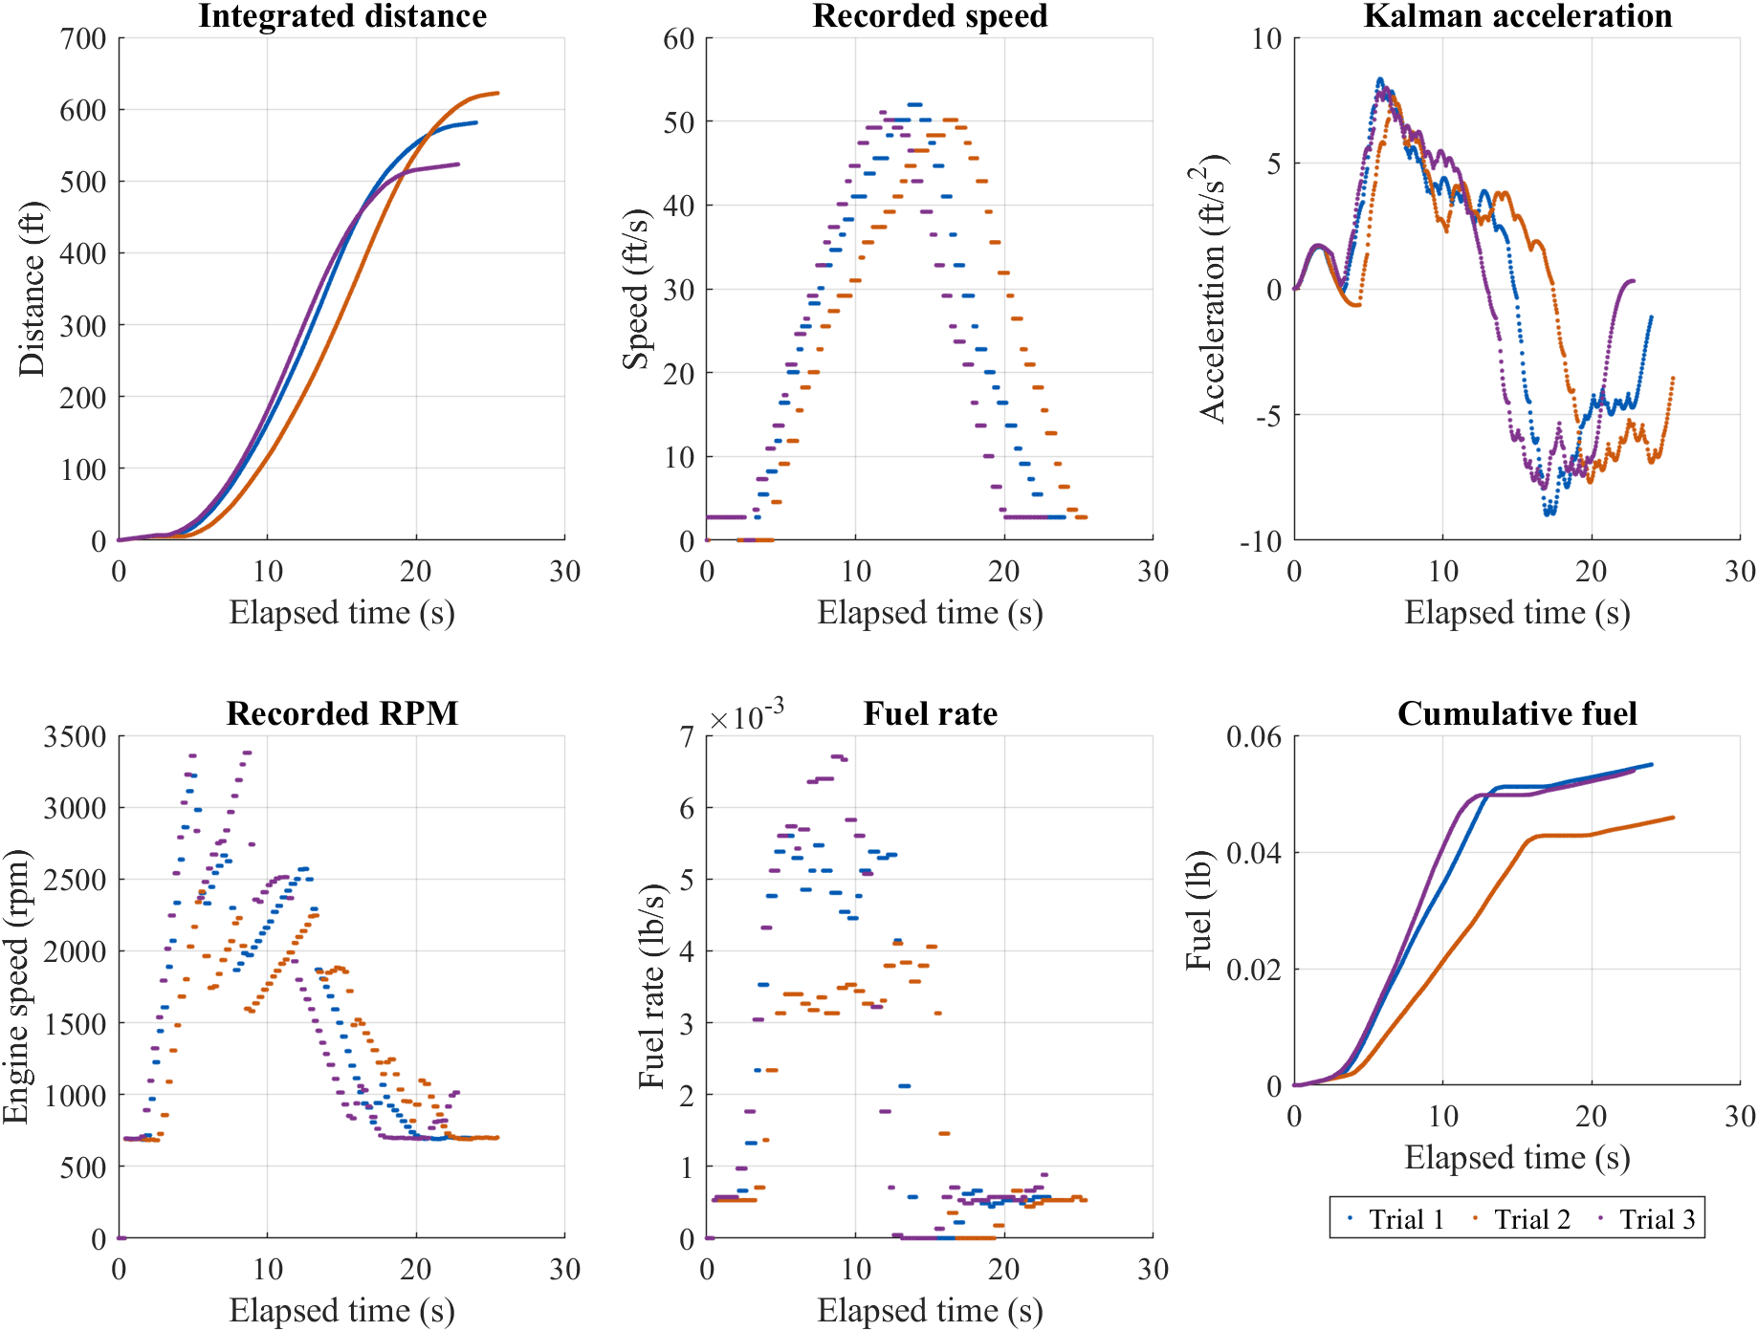
Fig. 2. Complete Camry records. Distance and fuel mass are cumulative trapezoidal integrals; acceleration is the Kalman estimate. The logs do not include a measured final stop. Fuel quantities remain in mass units.

Jetta phase fits
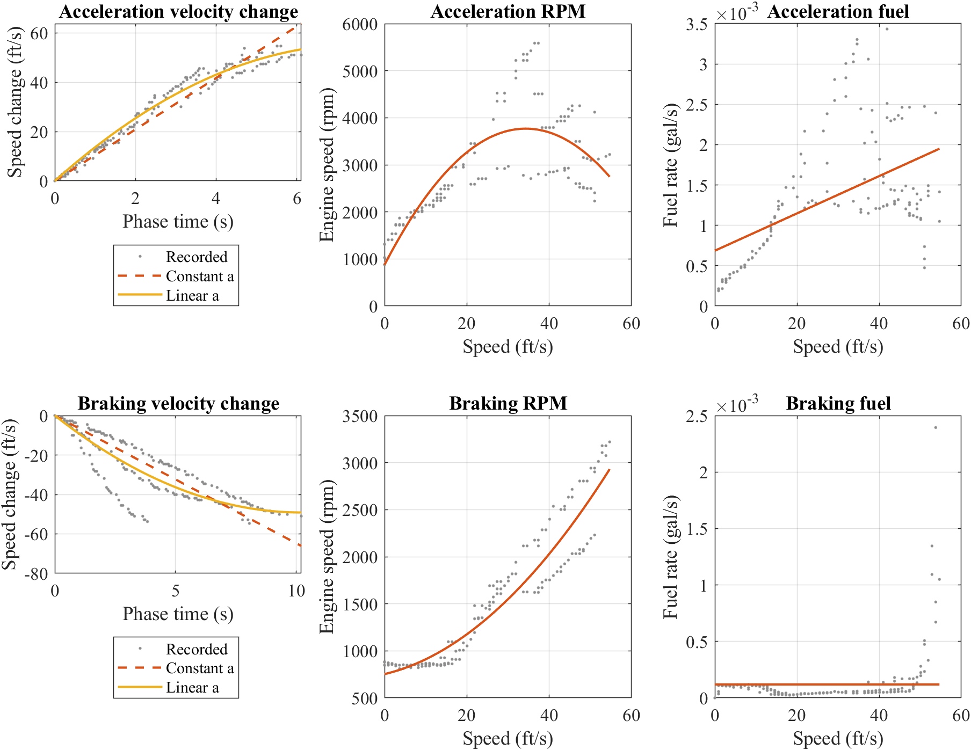
Fig. 3. Recorded phase samples (dots) and fitted curves (lines). The velocity panels compare constant and linear acceleration. RPM and fuel use separate acceleration and braking fits. The spread between trials is retained, rather than replaced with synthetic observations.

Camry phase fits
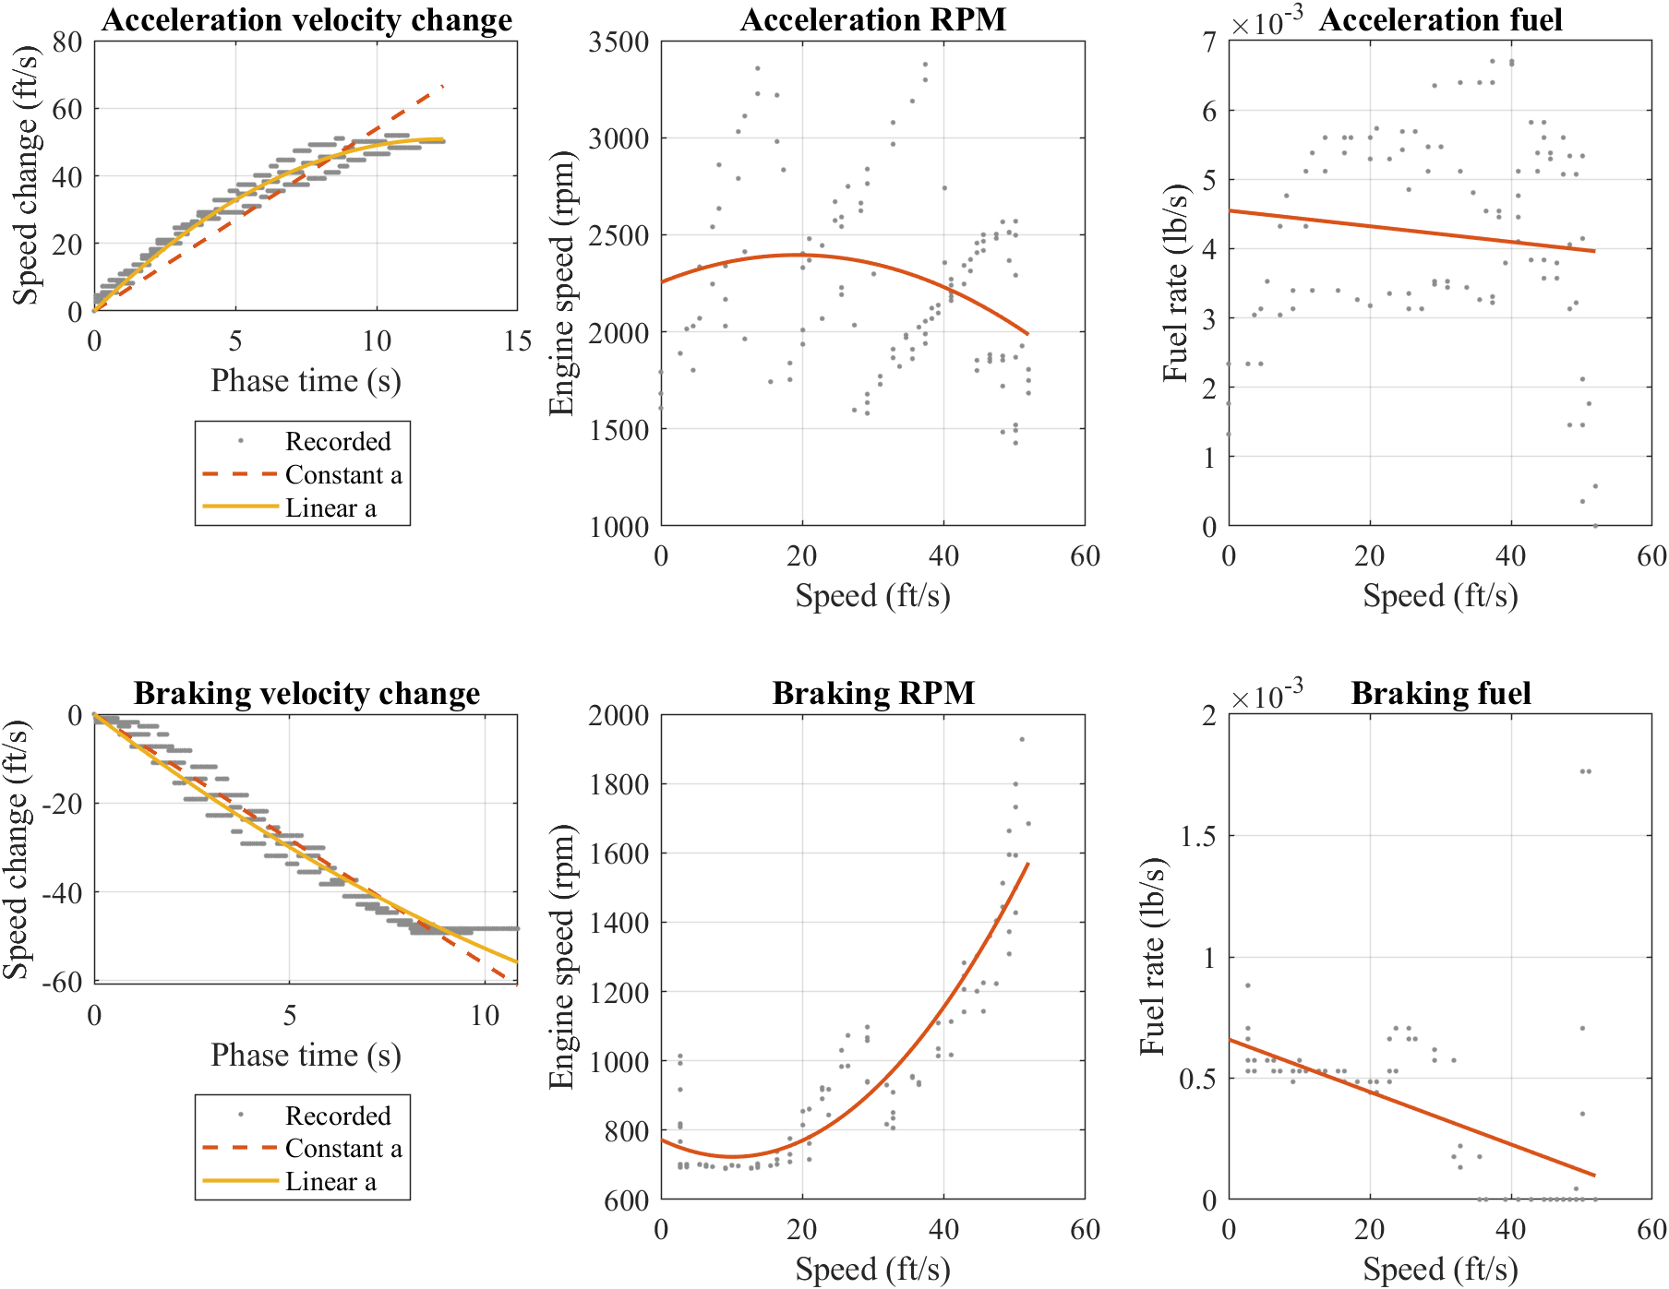
Fig. 4. Recorded phase samples and fitted curves. Camry fuel is mass rate in lb/s. The last recorded speeds remain above zero; course stopping predictions extend beyond those endpoints.

Jetta course predictions
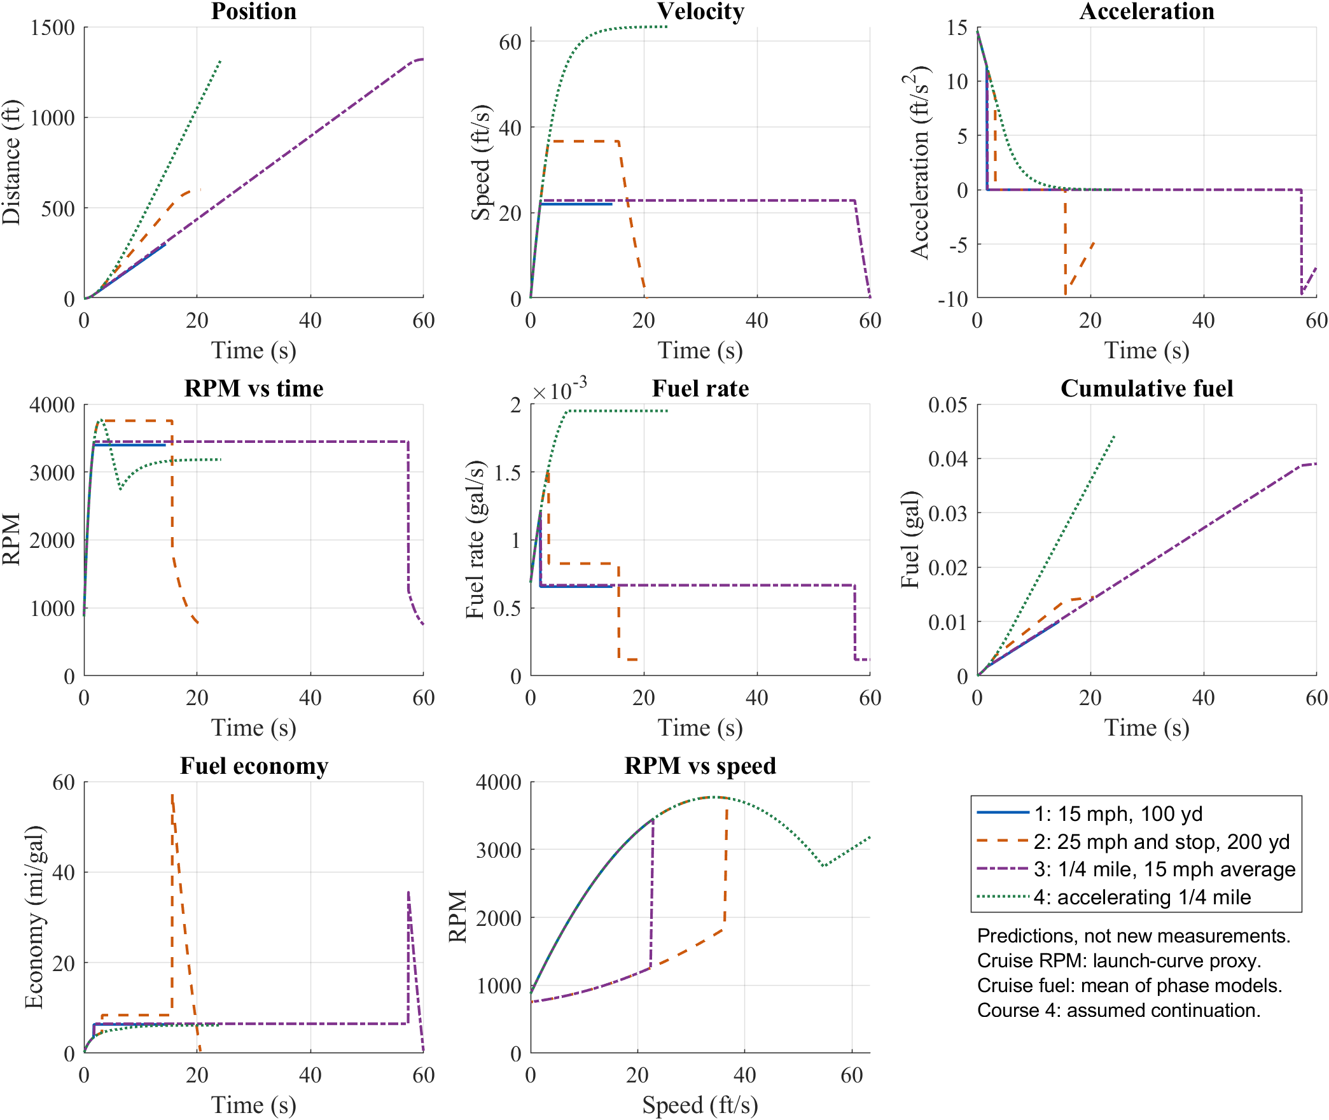
Fig. 5. Four modeled courses using the same fitted phase laws. Curves are scenario predictions, not additional measurements. Course 3 uses a chosen rest-to-rest profile; Course 4 uses the positive-acceleration extension. The cruise fuel estimate is assumption-dependent.

Camry course predictions
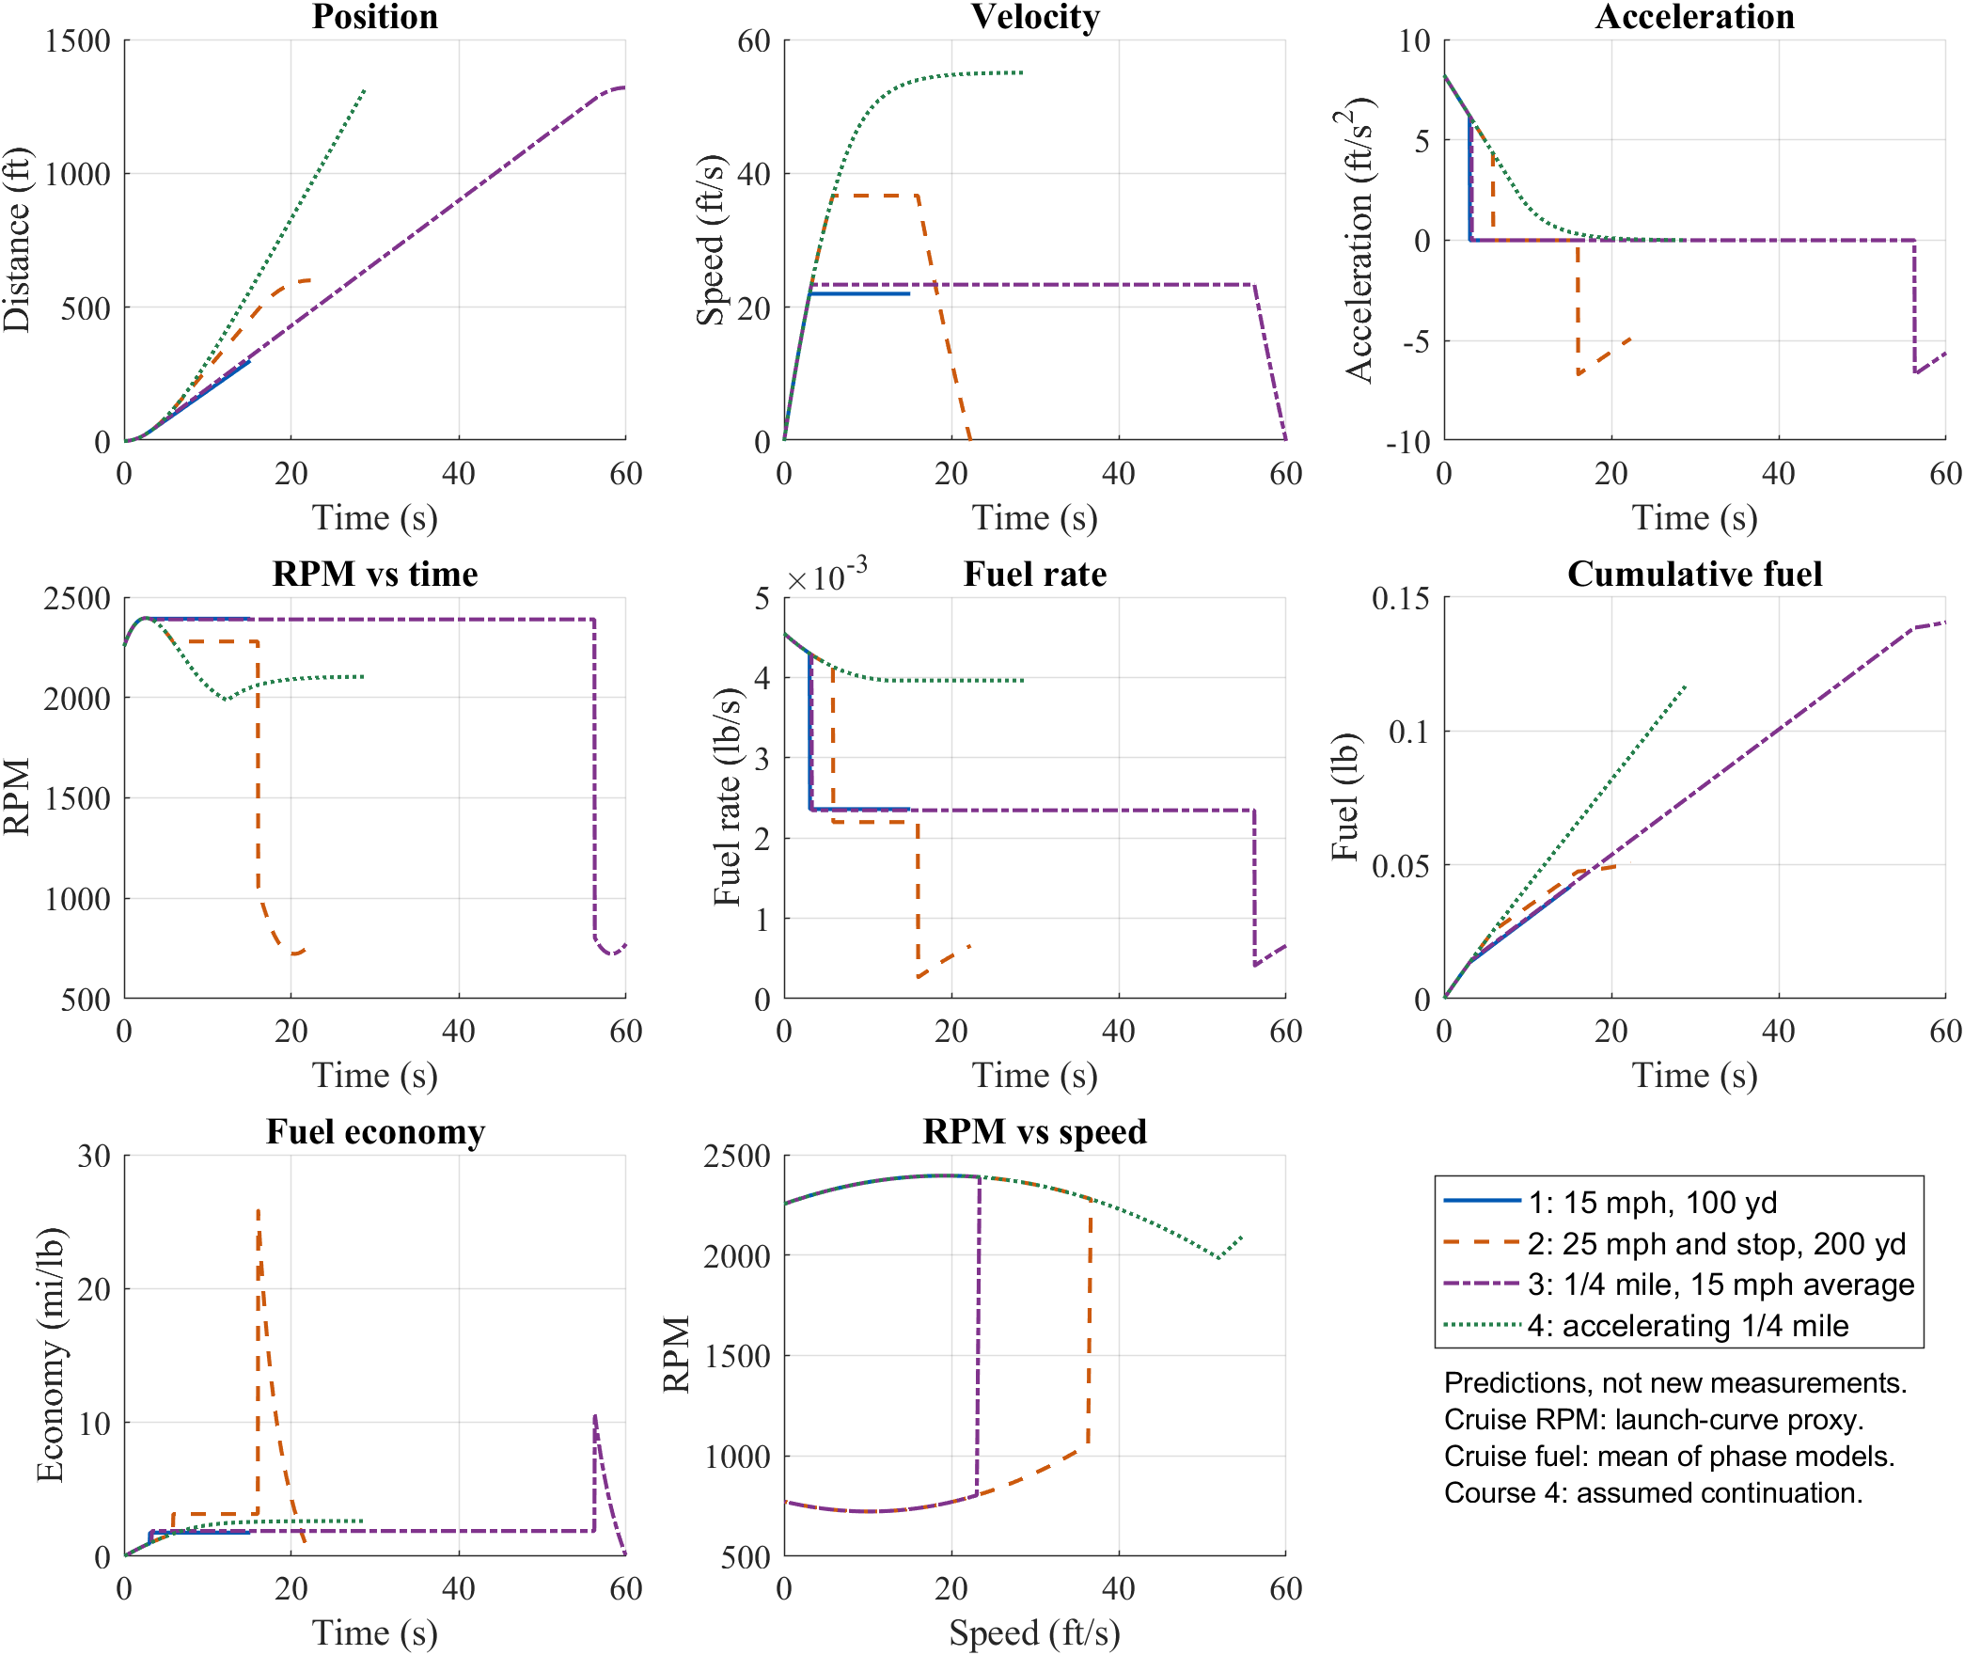
Fig. 6. The same course definitions applied to the Camry fits. Fuel economy is expressed as mi/lb, not MPG. Travel beyond the measured range and the final stop are extrapolations.

